Assignment  
PhoneGap on iOS

# 

## Install PhoneGap

Download and extract the latest version of [PhoneGap](http://phonegap.com/download) from http://phonegap.com/download.

## Project Creation

Xcode projects for PhoneGap are created by invoking a script file via the command line. The following steps explain how to create the necessary directory structure, open and use the Terminal application to create a new project, and execute the create script.

### Open Terminal

1. In Finder, navigate to the Applications Folder. Find and expand the Utilities Folder.
2. Locate the Terminal app and double click to open it.
3. In Finder, navigate to the phonegap/lib/ios/ directory from the downloaded and extracted Cordova code. Highlight the bin directory as shown:

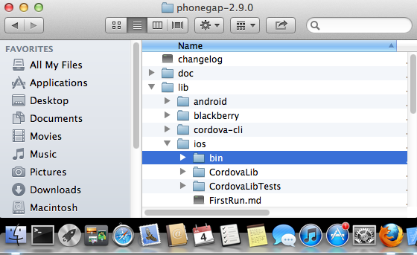

**Note:** This screen capture was from the Cordova-2.9.0 download, your listing will vary based on the actual Cordova version installed.

1. Drag bin directory to the open Terminal icon in the dock. This will open up a default terminal window with the path set to the bin directory.

### Create New Project

**Command Line Syntax**

1. Determine Required Parameters

There are 3 ordered, required parameters for creating a Cordova project from the command line:

* 1. **project location**
  2. **package name**
  3. **project name**

1. Execute the Command

In the terminal app with bin as the current directory, enter the 3 pieces of information via the following command:

./create ~/Desktop/HelloPhoneGap com.csc. HelloPhoneGap HelloPhoneGap

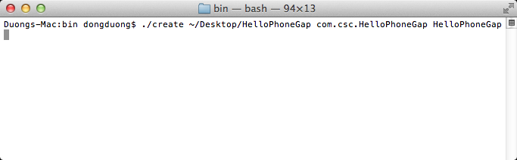

## Running the Application

### Open the Project

Using the Finder app, navigate to the location where you created the project. This guide uses ~/Desktop/HelloPhoneGap. Double click the HelloPhoneGap.xcodeproj file to open the project in Xcode.

Your screen should look similar to:

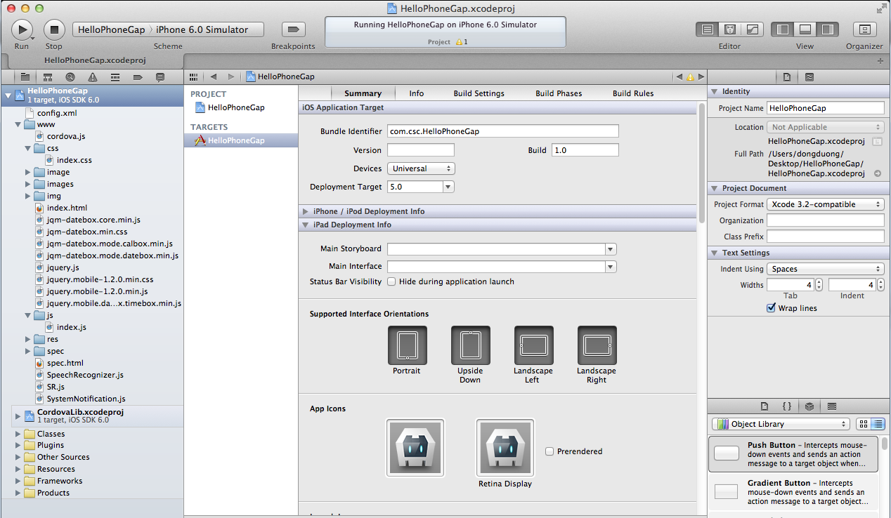

### Deploy to the Simulator

1. In the upper left hand corner of Xcode, click on the Scheme drop down and select the project name, HelloWorld, as the target.
2. Click the device section and select an iOS Simulator such as iPhone 6.0 Simulator as shown:



1. Click the **Run** button in your project window's toolbar to build, deploy and run the application in the simulator.

## Results

The running HelloPhoneGap app is shown below. The Device is Ready line should be slowly pulsating.

